**PROCESS AND METHOD  
FOR THE DEVELOPMENT OF DATA STANDARDS**

Version /// 1.0

Publication date /// 24 may 2019

Table of Contents

1. About this document 4

2. Introduction 5

2.1 Context 5

2.2 Scope 5

3. Principles 7

4. Process 8

4.1 Actors and responsibilities 8

4.2. Announce a data standard 9

Step 1. Develop and communicate a declaration of intent that describes the scope of the to be developed data standard 10

Step 2. Invite relevant and interested business stakeholders to a workshop meeting to identify processes and use cases 11

Step 3. Further develop declaration of intent into a Working Group Charter by adding requirements and conditions based on input from the business 11

Step 4. Present the Working Group Charter to the Permanent ICEG Working Group Data Standards for approval for starting a thematic working group 11

4.3 Development of a specification 11

Step 1. Set up the working group and environment 12

Step 2. Creating an initial draft 13

Step 3. Organizing the working groups 13

Step 4. Elaborate interim draft specification 13

Step 5. Mid-term evaluation by the data standards working group 13

Step 6. Organizing a public review 14

Step 7. Finalizing the specification 14

Step 8. Quality control by the permanent working group on data standards 14

Step 9. Assessing and confirm agreements made 14

4.4 Publication 15

Step 1. Publishing specification in both human and machine readable format 15

Step 2. Publishing reusable elements that project teams can make use of 15

Step 3. Publishing a conformity test suite 15

4.5 Change management 16

Step 1. Receiving feedback 17

Step 2. Processing changes 17

Step 3. Publication of a new version 18

4.6 Phasing out a standard 18

Step 1. Proposal for phasing out a standard 19

Step 2. Assessment of the proposal, announcement and implementation of a public review period 19

Step 3. Ratification of the decision to phase out a standard 20

Step 4. Publication of the phased-out standard 20

5. Method 20

5.1 Setting up a working group charter 20

5.2 Organising and facilitating working group meetings 21

5.3 Developing a domain model 22

5.4 Supporting transparency during development 24

5.5 Generation of the data specification and documentation 24

5.6 Management of issues and errors 25

6. Lyfecycle of a standard 26

6.1 Criteria for promotion to candidate standard 27

6.2 Criteria for promotion to standard 27

7. Addendum 28

7.1 Glossary 28

7.2 Other 29

# 1. About this document

**Latest update**

2019-05-24

**Latest version**

This document is by ICEG, Cooperation agreement between the federal, regional and community administrations on the harmonization and alignment of initiatives aiming to realize an integrated e-government.

Dit document van [Informatie Vlaanderen](http://vlaanderen.be/informatievlaanderen) is gepubliceerd onder de ["Modellicentie Gratis Hergebruik - v1.0"](https://overheid.vlaanderen.be/sites/default/files/documenten/ict-egov/licenties/hergebruik/modellicentie_gratis_hergebruik_v1_0.html).

**Auteurs**

Buyle, Raf - [Informatie Vlaanderen](https://overheid.vlaanderen.be/informatie-vlaanderen) - [raf.buyle@kb.vlaanderen.be](mailto:raf.buyle@kb.vlaanderen.be)

Scheerlinck, Jens - [PwC](http://pwc.be/) - [jens.scheerlinck@pwc.com](mailto:jens.scheerlinck@pwc.com)

De Keyzer, Michiel - [PwC](http://pwc.be/) - [michiel.de.keyzer@pwc.com](mailto:michiel.de.keyzer@pwc.com)

**Reviewers**

Vanlishout, Siegfried - [Informatie Vlaanderen](https://overheid.vlaanderen.be/informatie-vlaanderen) - [sigfried.vanlishout@kb.vlaanderen.be](mailto:sigfried.vanlishout@kb.vlaanderen.be)

D’Hondt, Liesbet - [BOSA](https://bosa.belgium.be/nl) - [liesbet.dhondt@bosa.fgov.be](mailto:liesbet.dhondt@bosa.fgov.be)

**Revision history**

Current status: Final

|  |  |  |  |
| --- | --- | --- | --- |
| Revision | Date | Colleborator(s) | Comment |
| 1.01 | 09/05/2019 | L. D’Hondt | Translation to English for ICEG |
| 1.00 | 04/04/2018 | J. Scheerlinck | Verwerken van feedback werkgroep datastandaarden en webcast |
| 0.07 | 22/03/2018 | J. Scheerlinck | Verwijderen van verwijzingen naar commerciële tools |
| 0.06 | 14/03/2018 | J. Scheerlinck | Verwerken ontvangen feedback na werkgroep sessie 28/02/2018 |
| 0.05 | 01/03/2018 | J. Scheerlinck | Verwerken feedback werkgroep sessie 28/02/2018 |
| 0.04 | 12/12/2017 | J. Scheerlinck | Toevoegen uitleg “specificatie” |
| 0.03 | 04/12/2017 | R. Buyle, J. Scheerlinck, M. De Keyzer | Finale draft |
| 0.02 | 20/10/2017 | R. Buyle, J. Scheerlinck, M. De Keyzer | Eerste ontwerp |
| 0.01 | 06/10/2017 | R. Buyle, J. Scheerlinck | Creatie document |

# 2. Introduction

## 2.1 Context

Governments at local, regional, inter-federal and European level often have to cooperate in the context of their services. In practice, a great deal of data must therefore be exchanged between the various administrations. This data comes from different systems, may not be available in the same technical format, and does not necessarily follow the same semantics. High quality data exchange becomes impossible without making agreements. These agreements must be anchored as broadly as possible and, where relevant, lead to a standard with a voluntary, 'comply or explain' or mandatory nature, in order to avoid unnecessary costs for data exchange.  
  
When developing standards by governments, it is important that the goals of the various stakeholders are aligned, also within the hierarchy of an organization. All parties involved must be aware of the benefits that effective and efficient use of the standards entail. In this case, the stakeholders must be convinced of the usefulness (whether or not directly for them). The development process set out in this document is based on international standards, guarantees sufficient support among stakeholders and provides for coordination with experts both within their own organization and from the professional field.  
  
The process and method are based on principles of openness and transparency, the stimulation of high involvement, and offering the necessary guarantees in terms of stability, quality and applicability. Moreover, standards exist in a changing environment, so there must be room for managed changes and maintenance of agreements and standards.

## 2.2 Scope

This document describes a scalable process and method for developing and modifying data standards, and managing the life cycle of these standards. The process and method are based on international best practices from ISA[1], W3C[2] and OpenStand[3], among others. This process is aimed at building consensus between different public administrations, and facilitating semantic, syntactic and technical interoperability. How this process can be organized is substantiated by means of a method. This describes a way of working to ensure clear communication and clear documentation throughout the process, so that the data can be implemented by all stakeholders such as project managers, business analysts , developers, ed.

The process and method described in this document form the basis for the development of a new data standard, adoption and modification of existing standards and the possible phasing out of those standards. In particular, this document is aimed at data standards for which a recognition procedure by ICEG steering is intended.

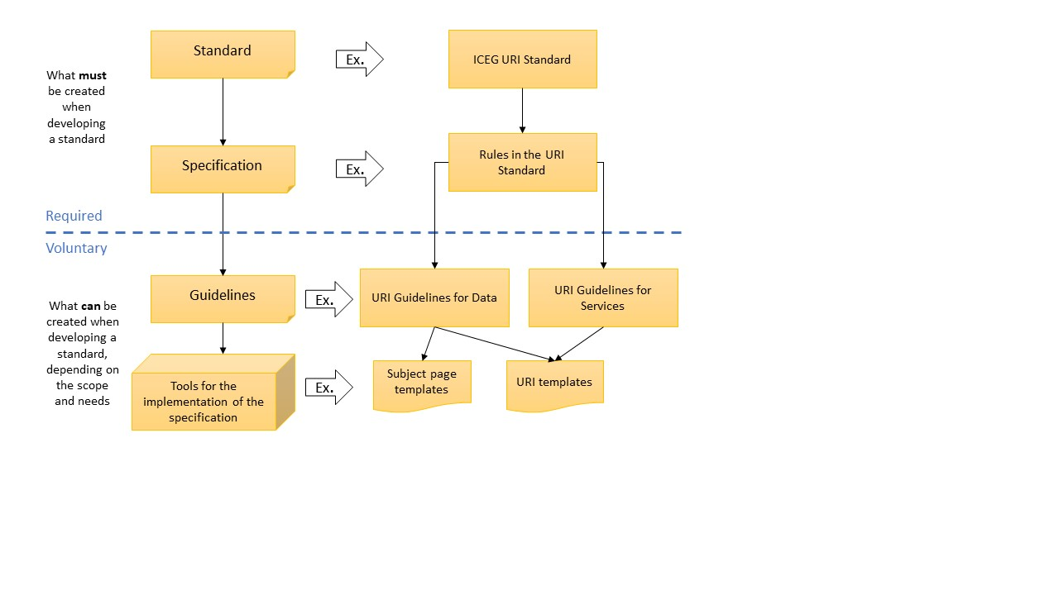

Figure 1: What must and what can be delivered in the context of the development of a standard

# 

# 

# 3. Principles

The process and method explained in the following chapters follow a number of fundamental principles for the development of standards, which are based on the principles for standards development of OpenStand[4]. These principles apply as best practices and have already been endorsed by, among others, W3C, IEEE, IETF, IAB and Internet Society.

1. The standard is developed in **collaboration with all stakeholders** and respecting everyone's autonomy, integrity, processes and intellectual property. Moreover, participation is free to all interested and informed parties.
2. The process is aimed at finding a **broad consensus**. Decisions are made in a **fair and transparent way**. Mechanisms are provided for appealing against decisions, as well as for a periodic assessment of the standards. Furthermore, all decisions and relevant documentation are made **publicly available**.
3. The standards being developed strive for **technical merit, interoperability and scalability**.
4. Standards together with their relevant documentation are **made available for implementation** by all parties. Specifications are being developed that allow implementation in an reasonable manner.

# 

# 

# 4. Process

The process for developing and maintaining data standards is divided into three high-level phases. These phases are further explained in sections 4.2, 4.3 and 4.4. First attention is drawn to the various actors and their responsibilities (4.1). The change management is explained in section 4.5. Finally, section 4.6 provides an explanation of the phasing out of a standard. How the processes explained in this chapter, in combination with the methods from chapter 5, are used throughout the lifecycle of a standard, is summarized in chapter 6: the lifecycle of a standard.

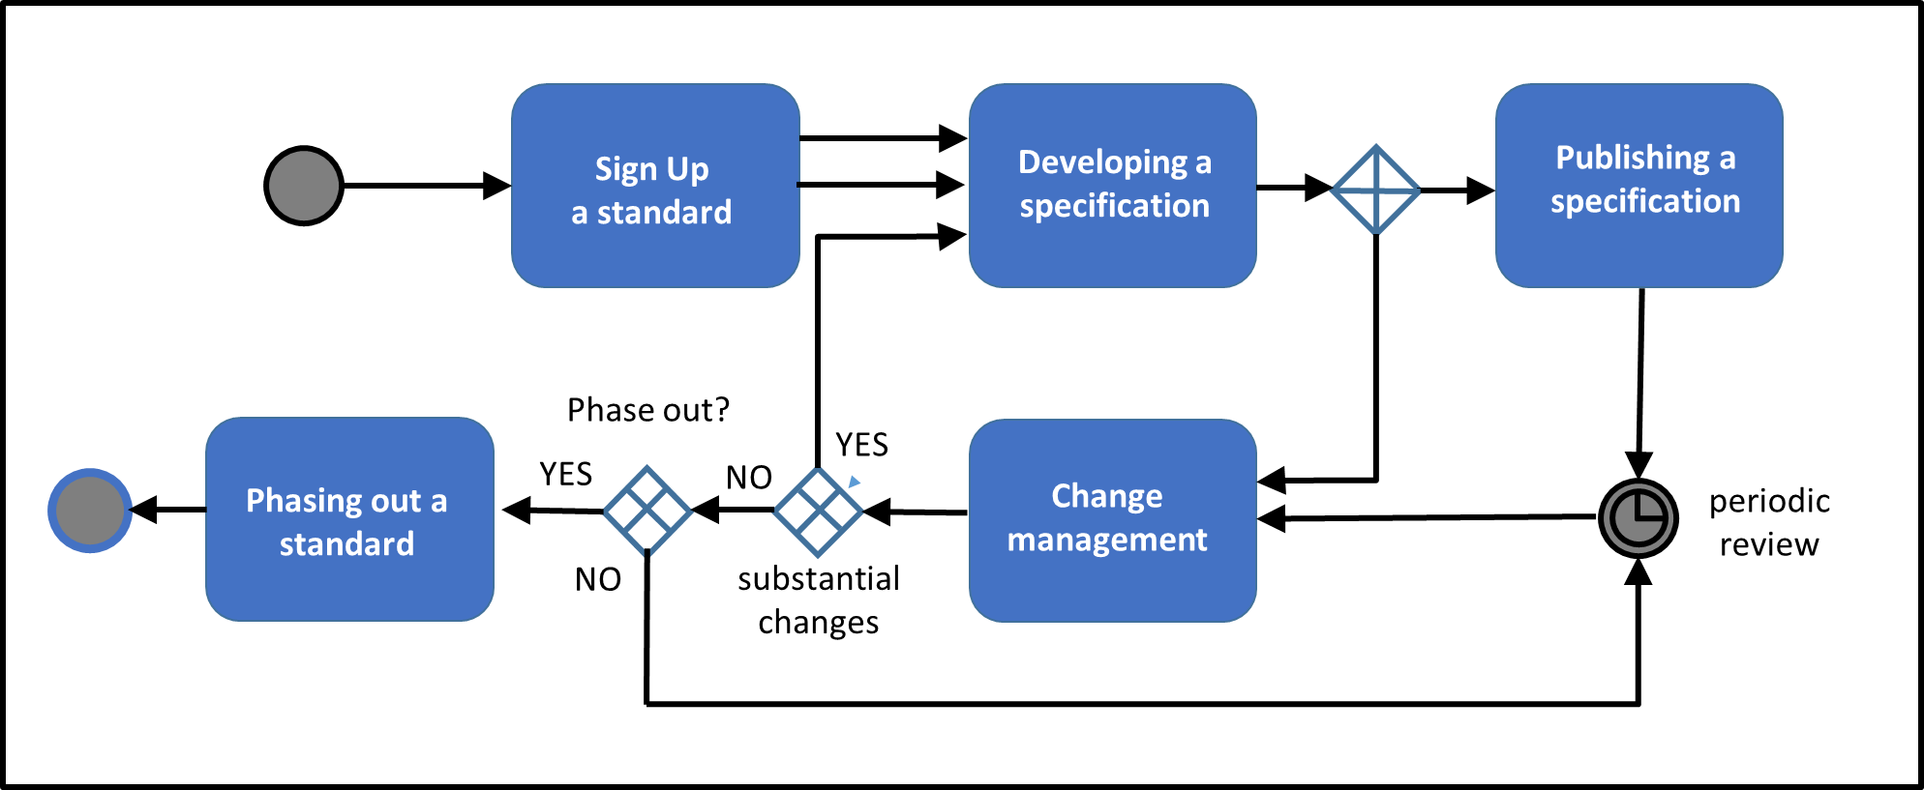

Figure 2: High-level overview of the different processes

## 4.1 Actors and responsibilities

The table below provides an overview of the actors participating in the process and their responsibilities. Each of these actors has an equivalent in the ISA methodology for developing semantic agreements[5].

|  |  |
| --- | --- |
| **Actor (ICEG)** | **Responsibilities** |
| Thematical Working group(s)[6] | This group of experts with knowledge of existing data models and implementations is responsible for the development of the domain model. |
| Editors of thematical working group(s)[7] | Are responsible for facilitating the working groups and the technical elaboration of the domain model in the form of diagrams and specifications. |
| Working group ‘data standards ICEG’[8] | The working group has a permanent character and is responsible for the central coordination and follow-up of work with regard to the standardization of information. The activities include the standardization of: meaning of the information (semantics), the syntax of the information (grammar), the technical standards for the exchange of information and the metadata ("data on data"). In addition, the working group monitors mutual consistency (system operation) in the recognition of new standards, monitors international standards that have an impact on governments in Belgium and is responsible for monitoring the generic development and change process. The data standards working group meets on a regular basis to evaluate the current thematic working groups. |
| Product owners | Product owners are responsible for managing a standard after its development. In concrete terms, they monitor problems or questions that are asked with regard to the standard, call the working group together in function of the questions asked and are responsible for the further development of standards in the context of new use cases or changes in underlying standards (dependencies). |
| ICEG[9] | Endorses the standards after reviewing the documentation of the process followed. |
| Project Management ICEG Data Standards[10] | Responsible for organizing working groups and inviting experts, as well as communication with various stakeholders. |

## 4.2. Announce a data standard

In line with the basic principles for standards development, it is necessary to report standards to the governing body (ICEG) in time and to reach a broad consensus.

To ensure a widely supported data standard, early involvement of the business is needed. Their knowledge makes it possible to map existing processes - together with the terminology used - and formulate use cases for the data standard to be developed. Moreover, a first High Level Domain Model can be drawn up together with the business. This information forms the basis for recording semantic agreements and already provides an insight into the relevance of the data standard in the initial phase.

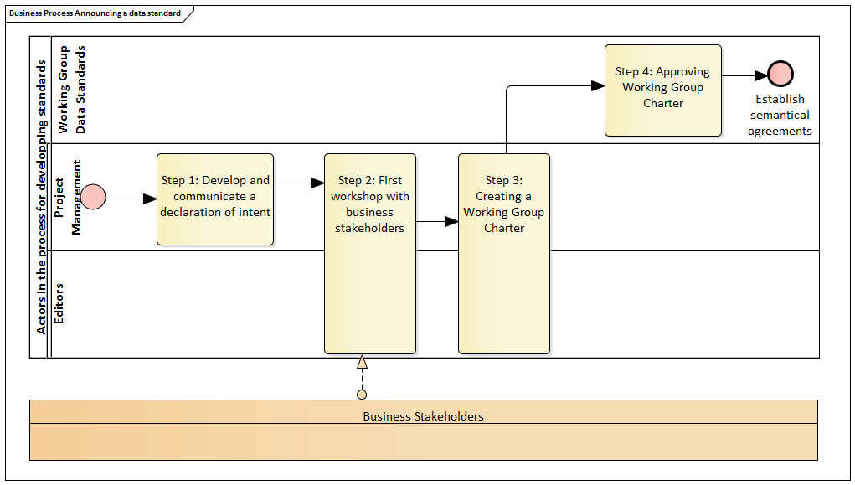

Figure 3: Process for the announcement of a standard

### Develop and communicate a declaration of intent that describes the scope of the to be developed data standard

The purpose of the declaration of intent is to answer a number of basic questions:

● Why is it important to develop this standard? What is the added value?  
● What is the interface with existing standards at local, Flemish, federal, European or global level?  
● Which standards and other sources already exist in this domain?  
● Who are the stakeholders that need to be involved and why them?

The declaration of intent is prepared by the project management. As an example, we refer to communication regarding the launch of a thematic OSLO working group on "public domain"[11].

### Invite relevant and interested business stakeholders to a workshop meeting to identify processes and use cases

The declaration of intent forms the basis for meeting for the first time with an initial group of stakeholders to identify different use cases[12] to which this standard can serve, starting from the processes. This session is organized by the project management and the editors and serves as preparation for the further development of the process for standards development, on the basis of which an official Working Group Charter is elaborated in the next step. If a thematic working group has already been established, the members of this group can also be invited to this workshop.

### Further develop declaration of intent into a Working Group Charter by adding requirements and conditions based on input from the business

The Working Group Charter sets the expectations for the deliverables that the thematic working group will produce. It allows the permanent working group on data standards to evaluate the relevance and applicability of the standard to be developed. For practical guidelines regarding the preparation of a Working Group Charter, see “5.1. Drawing up a Working Group Charter”.

### Present the Working Group Charter to the Permanent ICEG Working Group Data Standards for approval for starting a thematic working group

The charter is submitted to the permanent working group data standards for approval before the public working groups can start working on the development of a specification. Once this has been approved by both bodies, the registration of the standard is successful and the standard is entered in the standard register with the status “under development”. The permanent working group data standards and the ICEG steering committee meet on a regular basis. The evaluation and discussion of these charters will always be an agenda item. As part of the treatment of the charter, it is decided in consultation with the thematic working group whether the standard to be developed aims for a voluntary, "comply or explain" or mandatory nature.

## 4.3 Development of a specification

A specification is a technical document that gives substance to the standard. In practice it is often difficult to distinguish the specification from the standard itself. Typical examples in this regard are PDF-A, DCAT and RDF. In some cases, multiple specifications are part of a standard. These specifications then each give a domain-specific interpretation to the standard. An example of this is the INSPIRE Data Specifications[13], which provide a domain-specific interpretation of the "INSPIRE Implementing Rules" (the standard) for each of the INSPIRE themes.

The process for developing a specification is based on the process for the ISA process for developing semantic agreements[14]. This process must be followed for the development of a specification for data standards such as domain models and controlled vocabulary.

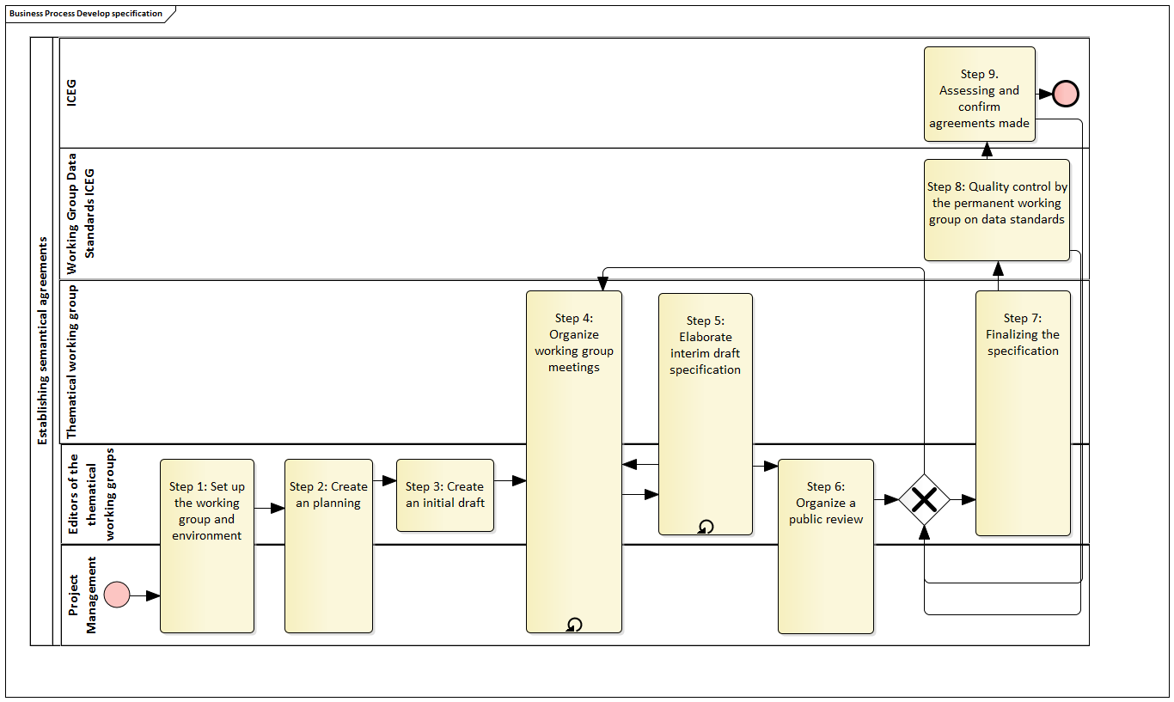

Figure 4: process for the development of a standard

### 

### Set up the working group and environment

In this step, the practical side of the organization of the working group is set up. This means that a project environment is set up, the members of the working group are invited and the composition and assignment of roles is recorded. The standard to be created is now in the "in development" phase. Furthermore, the planning for organizing the working group meetings, the public review and finalization is created.

### Creating an initial draft

Based on the knowledge at the start of the process, for example based on available project documentation, wireframes, process descriptions, elaborated use cases and existing models and standards, a specification version is prepared. Questions and any problems that arise from the analysis are listed in an action list. A proposal for a solution is created for as many listed action points as possible. This will serve as a starting point for discussions in the working group meetings.

|  |
| --- |
| **Formalizing semantic agreements**  Formalizing semantic agreements is a specialization of the process for developing a specification. When creating an initial draft, the method for developing a domain model as described in section 5.3 is used. |

### Organizing the working groups

The project manager and editor together prepare the agenda for the working group meeting, based on open points that arise from the analysis and / or the previous working group meeting. During the working group meetings, the members of the working group go through the initial or intermediate draft of the specification, and through the various items on the agenda that are listed in the action list, and try to reach a consensus.

### Elaborate interim draft specification

The conclusions of the working group meeting are processed in a new interim draft. Any new points that were identified during the working group or during the development of a new draft are added to the action list and serve as input for creating the agenda for the next working group meeting.

|  |
| --- |
| **Formalizing semantic agreements**  Formalizing semantic agreements is a specialization of the process for developing a specification. When creating an interim draft, the method for developing a domain model as described in section 5.3 is used. |

### Mid-term evaluation by the data standards working group

A stable interim draft specification is proposed to the data standards working group, together with an overview of the organized working group sessions and the parties involved. The data standards working group decides whether the specification is sufficiently mature to switch to a public review period and uses the criteria for promotion to a proposed standard for this. The duration of the public review period is determined in consultation between the thematic working group and the data standards working group.

### Organizing a public review

After completing various iterations of steps 4 and 5, and once there is sufficient consensus around the specification, a public review period is organized, in which the general public is asked to provide feedback. This public review can be accompanied by the organization of extra public workshops to capture feedback. Based on the feedback received, there are two options:

1. The feedback received is editorial or results in minor semantic changes (see 4.5. Change management related to receiving and classifying feedback): The final version of the model can be prepared and publication can be made, provided that a short validation is possible by the thematic working group.
2. The feedback received includes proposals for major semantic changes: one or more additional working group meetings are needed to clarify the new actions and reach consensus again. If this is deemed necessary by the working group, a new public review can be organized again.

The standard ends up in the "pending" phase at the start of the public review period and receives a publication status of "proposed standard". Before this phase can be started, the project management together with the editors of the working group and the working group must test data standards to see whether all criteria for promotion to proposed standard have been met (see step 5). The public review period, during which the specification is stable (no changes are made until the end of the public review period), is ideal for creating and evaluating proof-of-concept implementations of the specification. These proof-of-concepts can be carried out by members of the thematic working group or by external interested parties.

### Finalizing the specification

The editors process, when necessary in consultation with the thematic working group, all feedback received. This results in a final, stable version of the specification and accompanying documentation.

### Quality control by the permanent working group on data standards

The permanent working group on data standards performs a quality check to ensure that the process has been followed correctly and whether the objectives described in the Working Group Charter have been achieved. If the work is assessed positively, it will be submitted to the ICEG steering committee for ratification, otherwise the thematic working group may be asked to go through (part of) the process again. The data standards working group uses the criteria for promotion to standard for this quality control.

### Assessing and confirm agreements made

The final domain model, associated specification and documentation is formally submitted to the ICEG steering committee by the permanent working group on data standards, together with a report describing the process that has been completed. After the assessment the domain model can be promoted to a data standard (see criteria for promotion to standard), the standard is then in the “in use” phase, or the steering body can ask the thematic working group to go through (part of) the process again .

## 4.4 Publication

To promote the adoption of the data standard, it is necessary to provide technology as an aid to start using it. Therefore, following the development of a specification, at least the following steps are taken that are aimed at providing developers, information architects and other stakeholders with the necessary documentation and resources to implement the data standard:

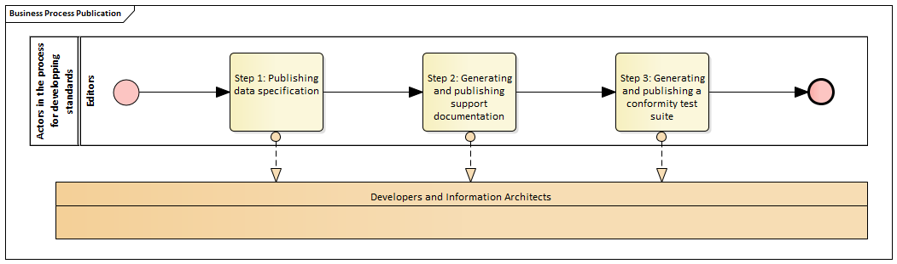

Figure 5: process for the publication of a standard

### Publishing specification in both human and machine readable format

The data specification allows developers and information architects to estimate the impact on existing and new applications. It provides insight into how a standard can be used. Finally, a machine allows readable data specification to automate certain aspects of the adoption. The standard is included in the standards register with the status “in use”, with a reference to the specification that is published on belgif.be.

### Publishing reusable elements that project teams can make use of

Reusable elements, such as a JSON-LD context file in which a data specification (eg in the case of OSLO a vocabulary) is translated into a list of terms, along with their identifier, that can be used to create a compliant JSON payload [15]. Other examples are the "subject pages[16]" that are made available as standard to support the URI.

### Publishing a conformity test suite

A conformity test suite allows you to validate implementations and ensures correct adoption of standards. Examples are the SHACL [17]validator for OSLO and the "INSPIRE Validator" of the European Commission[18].

## 4.5 Change management

A standard, no matter in what of its lifecycle, can be subject to feedback and necessary changes. It is important that this feedback is captured and evaluated in a structured way, and a clear, repeatable and transparent process to deal with it.

Change management ensures that there is the necessary guarantee that changes, if necessary, are coordinated with the necessary stakeholders and that the impact of changes is taken into account.

The change management process is aligned with the corresponding process[19] developed by the ISA Program, and is based on the following principles:

* **Openness**: Openness means that feedback can be given on the standards and their underlying specifications by anyone and that logging, analysis and decisions are done in complete transparency.
* **Controlled change**: Changes must be step-by-step and traceable, taking into account the possible impact for those parties who have already implemented the standard.

Change management applies to those phases of the lifecycle where the standard is "stable":

Veranderingsbeheer is van toepassing in die fasen van de levenscyclus waar de standaard “stabiel” is:

* Candidate standard
* Standard
* Candidate revised standard

Feedback can be given at any time, and is evaluated, logged and treated according to the process described below. Feedback while the standard is "under development" or "under review" is immediately taken into account during the (re) definition according to the process described in the section "developing a specification", unless the working group decides to park it and to include it in a next release. We also refer to the method for managing issues and errata.

The change management process consists of the following major steps or sub-processes:

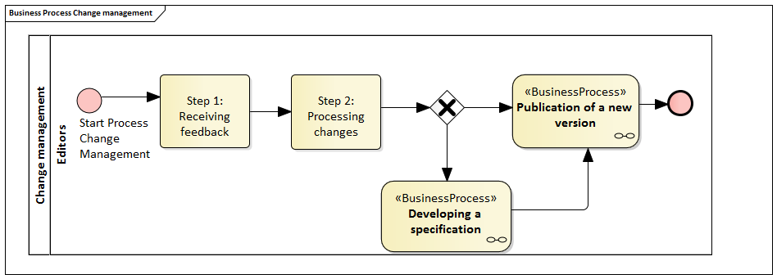

Figure 6 Process for change management

### Receiving feedback

In this step, the feedback received is captured and evaluated for relevance. This is the responsibility of the product owner. If the feedback is assessed as relevant, it is logged. If not, the relevant stakeholder will be notified and the feedback will not be logged. The feedback can come from, among others, people or organizations that implement the standard in their applications, see conflicts with other standards or provide new use cases that the standard must accommodate.

The logged feedback is then subjected to an evaluation to determine further processing. In particular, an evaluation is made of the type of change that may be required to the standard and its underlying specifications:

* **Editorial changes and errors**: These are changes that have no impact on the applications that have implemented the standard, for example additional clarification, typing errors, etc.
* **Minor substantive changes**: Examples of minor substantive changes in the context of semantic data standards such as OSLO are: the addition of a property and making certain restrictions stricter or less strict. These changes have a (possible) impact on implementations, but a small impact.
* **Major substantive changes**: These changes impact fundamental matters in the specification and underlying specifications, for example by changing a definition, adding classes, removing properties or fundamentally changing audited vocabulary. Existing implementations will be forced to analyze the impact and, where necessary, make changes in order to remain in conformity with the (new version of the) standard.

### Processing changes

The processing of changes depends on the type of change listed above:

* **Editorial changes and errors:** These changes can simply be implemented. A new version does not necessarily have to be published and, for example. erratum to be published.
* **Minor substantive changes:** For these changes, the process for developing a specification must be followed. However, for minor changes this can be a shortened procedure, in which the thematic working group is convened to discuss the issues and then implement the changes in a new version of the specification. When it comes to a standard that is already "in use" (cf. lifecycle of a standard), a period of public review is started and the specification receives the publication status "Candidate Revised Standard".
* **Major substantive changes:** For these changes, the entire process for developing a specification must be run through, including a new public review period, regardless of the lifecycle phase in which the standard is located.

It is important to note that logged changes should not be treated one by one. Once logged, these can be bundled and included in the specification according to a predefined release cycle. The frequency or the criteria with which a new release is carried out must be laid down in the Working Group Charter.

When it is decided to process the feedback received in a new version of the specification (in the case of small or large substantive changes), the lifecycle phase starts "in revision". The feedback can also trigger the phasing out of a standard, for example when it appears that it has been completely surpassed by technological changes. We refer to the process for phasing out of a standard.

### Publication of a new version

After analyzing and implementing the changes, according to the processes required according to the type of change, a new version of the standard, the underlying specifications and the supporting documentation must be prepared and finally published. Older versions of the standard and the underlying specification remain available and contain references to the most recent version. The version is determined by the publication date and not by incremental version numbers.

## 4.6 Phasing out a standard

A standard can be phased out, for example when it is outdated by technological evolution or when significant errors are found in the specification.

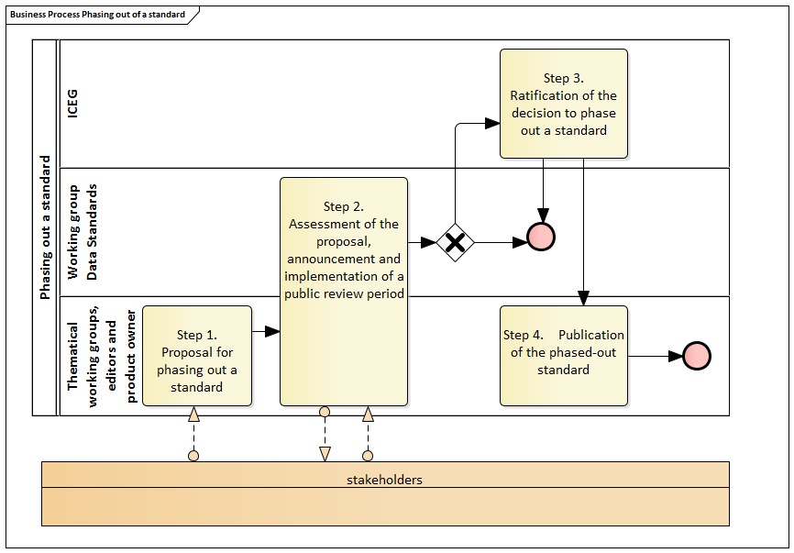

Figure 7 Process for phasing out a standard

### Proposal for phasing out a standard

When feedback received from stakeholders shows that a standard is obsolete, or when significant errors are found, the product owner of the standard can decide to submit a proposal to the working group, in consultation with the editors and the members of the thematic working group data standards, for phasing out the standard.

### Assessment of the proposal, announcement and implementation of a public review period

The data standards working group evaluates the proposal and, if admissible, announces a public review period, during which all interested stakeholders can provide feedback on the proposal to phase out the standard. This public review period lasts at least four weeks and is also intended as a transitional period, during which the standard is still in use.

### Ratification of the decision to phase out a standard

If no valid objections were raised during the public review period, the steering body can confirm the decision to phase out the standard.

### Publication of the phased-out standard

The product owner, editors and thematic working groups publish a version of the specification with the publication status “phased-out standard”. This publication also includes the reason for phasing out the standard.

# 5. Method

The method describes how the process can be set up based on a number of (technical) documents to ultimately result in a data standard. First the method is explained to arrive at a domain model. It is then explained how the transparency of the process can be guaranteed by producing relevant documentation. The following chapter provides an overview of the tools that can be used to generate the documents listed.

## 5.1 Setting up a working group charter

The Working Group Charter is based on an artifact from the W3C Standardization process[20]. This document is created in the first phase of the development process of a standard and sets expectations for the deliverables that the thematic working group will produce. The charter contains the following information:

* The objective and scope of the thematic working group (eg the development of a data standard for domain X).
* The evaluation criteria that are used during the development process. For example, whether and how many implementations have to exist before the standard can be approved and the nature of these implementations (proof -of- concepts or production implementations).
* The duration of the working group (eg 6 months).
* The type of deliverables (eg specification document, software component).
* Expected milestones (dates), when known.
* The internal process of the thematic working group for approving deliverables (for example, unanimity, or unanimity minus one).
* Dependencies between these and other thematic working groups, within or outside ICEG.
* Modalities for the working group meetings such as location and frequency.
* If available, the date of the first face- to- face meeting.
* Communication mechanisms ( eg GitHub repository, mailing list , Google Drive folder, etc.)
* Information regarding intellectual property and licenses.
* The frequency that the criteria based on which issues after the publication of a standard will be dealt with and new releases will be prepared. In other words, how are change management and release management arranged in a practical way?

## 5.2 Organising and facilitating working group meetings

The working group consists of a collection of domain experts and stakeholders with knowledge of existing use cases and implementations. Invitations to working group meetings are issued by the project management which have a view of relevant stakeholders and experts through their CRM system.

A typical development process will require at least three working group meetings, which can be structured as follows:

1. Become familiar with use cases and existing standards

* Explain the working group structure and used tooling for communication and follow-up.
* Explaining existing use cases, eg based on a few guest speakers.
* Brainstorming session (possibly in subgroups) around other relevant use cases and information needs.

1. Substantive discussions concerning the thematic domain

* Discussing draft specification
* Discussing open issues
* Preparation of action and discussion points

1. Finishing and concluding specification

* Discussing remaining discussion points
* Discussing final specification
* Testing of specification against use cases

Additionally, extra working group meetings can be scheduled for substantive discussions, with the entire working group or with a subset of this group to discuss specific topics. It is the role of the editors of the working group to prepare and moderate the meetings, their taks include:

* Preparing agenda items
* Timekeeping during working group meeting
* Taking minutes of the working group meeting
* Facilitating discussions

Prior to each working group meeting, the following documents are forwarded to the participants in preparation:

* Latest version of the domain model with a summary of any changes.
* Up-to-date overview of action and discussion points (consolidation of previous working group session + online discussions between the working group sessions)
* Report from previous workgroup session
* Practical information and agenda for the next working group

Following each working group session, the following information is sent to the participants:

* Report of the meeting including links to the documents that were used (eg draft specification)
* Invitation for participants to continue discussions via GitHub.

## 5.3 Developing a domain model

The development of the domain model takes place in thematic working groups and requires input from various stakeholders. The figure below provides an overview of the various steps for developing a domain model. This method is based on the ISA process and method for recording semantic agreements[21] and the W3C Process Document[22].

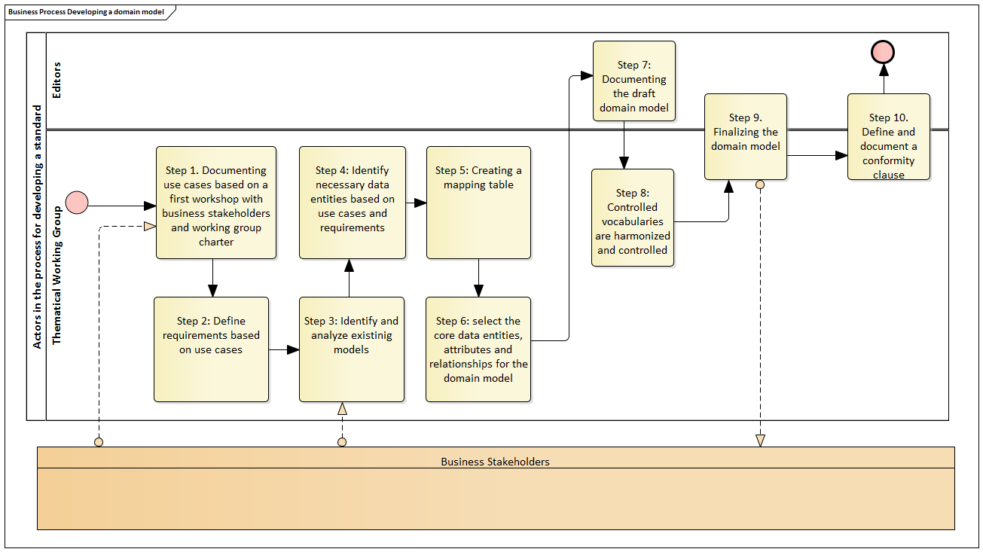

Figure 8: Developing a domain model

1. Based on a first workshop with Business Stakeholders and the information in the Working Group Charter, Use Cases are created to accommodate the data as a standard. These can be documented in a separate document or later contained in the specification of the domain model or the definitions and description of the data entities[23].
2. Requirements are distilled from the use cases with which the data must comply as a standard. For example, based on Use Case X we can deduce that the following data entities, attributes and relationships are needed ...
3. The Use Cases and Requirements make it possible to make an overview of the information needs (data entities, attributes and relationships) that are required in the domain model.
4. The working group identifies and analyzes existing models (and data standards), both at the level of individual business applications and applicable international standards (W3C, ISA, IETF, etc.)
5. A mapping table is prepared to compare the information needs with existing models and data standards. This is done based on the SKOS matching principles[24] . An example and template of such a mapping table can be found on the [OSLO Google Drive](https://translate.google.com/translate?hl=nl&prev=_t&sl=nl&tl=en&u=https://docs.google.com/spreadsheets/d/1n4-AELdNF9anB8199phtSbSGD4EMY-P6YU8Fa22MprM/edit%3Fusp%3Dsharing) .
6. The mapping table from the previous step makes it possible to . Where possible, existing models and data standards are reused and sufficient attention is paid to the elaboration of the new elements.
7. A draft domain model is created and documented. This leads to (1) a UML class diagram of the domain model and (2) a data specification in the form of a vocabulary document in both human-readable and machine-friendly format. Examples of this can be found on [http://data.vlaanderen.be](https://translate.google.com/translate?hl=nl&prev=_t&sl=nl&tl=en&u=http://data.vlaanderen.be) , section 4.4 explains which tools can be used to generate these artifacts.
8. Controlled vocabularies (code lists, taxonomies, thesauri, etc.) are harmonized and recorded.
9. The domain model is finalized. Furthermore, controlled vocabularies, along with any other restrictions such as cardinalities , can also be included in the specification. This leads to a new version of (1) the UML class diagram , (2) the vocabulary document and (3), if controlled vocabularies and other restrictions were added, an application profile. Examples of application profiles can also be found on [http://data.vlaanderen.be](https://translate.google.com/translate?hl=nl&prev=_t&sl=nl&tl=en&u=http://data.vlaanderen.be) , the relevant tooling is explained in section 4.4.
10. Finally, a conformity clause must be determined and documented. This determines what demands an implementation of the data standard must meet in order to conform to the data specification. Examples of this can be found in the vocabulary and application profiles at [http://data.vlaanderen.be/ns](https://translate.google.com/translate?hl=nl&prev=_t&sl=nl&tl=en&u=http://data.vlaanderen.be/ns) .

## 5.4 Supporting transparency during development

To support transparency of the development process of the standard, the following documents or resources are made publicly accessible:

* The Working Group Charter will be published on the standards register on Belgif.be after approval by the steering body.
* Reports of meetings held by the working group are made publicly available in HTML format on the standards register on Belgif.be .
* Design documents (draft domain model, design data specification, etc.) are published with each new version on the appropriate page at Belgif.be. The standards register always refers to the most recent version.
* Final domain models, in the case of standard semantic data, are included in the central Belgif repository .
* All interested parties can provide feedback on the standard and the developed specifications. This can be done via an easy-to-use and publicly accessible mailing list and / or issue log, which is kept in a GitHub repository of ICEG.
* Publish design documents for each new version on the appropriate page on belgif.be

## 5.5 Generation of the data specification and documentation

A specification is a technical document that gives substance to the standard. Specifications can be adjusted based on advanced insight without changing the corresponding standard. It is often difficult to distinguish a specification from the standard itself. Typical examples in this regard are PDF-A, DCAT and RDF. In some cases, multiple specifications are part of a standard. These specifications then each give a domain-specific interpretation to the standard. An example of this are the INSPIRE Data Specifications, which provide a domain-specific interpretation of the 'INSPIRE Implementing Rules' (the standard) for each of the INSPIRE themes .

The following method and toolchain were developed in OSLO to generate a data specification. This method uses the Resource Description Frame (RDF) as the underlying data model, but can also be serialized to a traditional XML.

All ICEG models are modeled in UML. All models are managed in a central ICEG repository to expose dependencies and perform quality control. You can find the most recent version on GitHub.

Modelling

Transformation

Generating specifications and artifacts

Publication

The UML models are transformed into an ontology in Turtle[25] syntax, using RDF, the EA tool to -RDF. This is the machine-readable version of an ICEG vocabulary. In addition, this tool can export a UML model of an application profile to a .TSV file for further processing. More information about the tool and the configuration used for the ICEG models can be found on GitHub. Furthermore, the output is easy to convert to other formats such as XML or JSON.

Based on this machine-interpretable version of the vocabulary, a number of artifacts are then generated with an Specification Generator tool. Successively with this tool the following documents are generated: HTML version of the vocabulary, HTML version of the application profile and the JSON-LD context definition. An XML schema can also be defined from this.

The output is subjected to a review using the Ontology Pitfall Scanner[26], Turtle syntax validator [27]and JSON-LD validator[28]. The models together with their documentation are then published on the ICEG Vocabularies GitHub repository, after which they are also made available automatically via belgif.be .

## 5.6 Management of issues and errors

All interested parties must be given the opportunity to log issues related to the standard and the specification. This must be done in an open and transparent manner.

The product owner of the standard monitors the issues . This means he is responsible for answering questions and, where necessary, calling in experts to answer specific questions. Furthermore, it is also the product owner who, based on the frequency and / or the criteria with regard to new releases of the standard, as stated in the Working Group Charter , convenes the members of the thematic working groups to discuss the issues and changes to the standard and to prepare its specification (see change management).

Changes to the standard must be documented on a webpage that was provided for this task. The minimum information per release includes :

●        The date of the release.

●        A textual description of the change.

●        Where possible, references to the issues that were dealt with and processed as part of the release.

# 6. Lyfecycle of a standard

The life cycle of a standard, and the status that the standard has in the standards register is based on the W3C Recommendation Track[29]. The table below provides an overview of the life cycle of a standard and the link with process and method.

|  |  |  |  |
| --- | --- | --- | --- |
| **Lifecycle phase** | **Publication status** | **Process** | **Method** |
| N / A | Working Group Charter[30] | Registration of a data standard | Setting up a Working Group Charter |
| In development | Draft document[31] | Development of a specification | Development of a domain model |
| In treatment | Candidate standard[32] | Change Management | Generate data specification and documentation |
| In use | Standard (+ Errors) [33] |
| In revision | Draft document  Candidate Revised Standard[34] | Development of a specification | Management of issues and errors |
| Phased out | Phased-out Standard[35] | Phasing out a standard | N / A |
| Working group ended (work stopped before the "in use" phase was reached) | Working group Report | N / A | N / A |

## 6.1 Criteria for promotion to candidate standard

* All documented use cases and requirements in the Workgroup Charter at the start of the work have been met.
* Any changes in dependencies were documented.
* The criteria for evaluating the implementation experience were defined and approved by the Working Group data standards (eg, minimum two implementations or proof -or- concepts ).
* A deadline for giving feedback must be specified.
* Demonstrate that the specification has already been assessed by a wide audience based on those involved in the working group and receive feedback via the mailing list and / or issue log.
* Certain data entities may be labeled as "at risk". These may be removed before the candidate standard is promoted to standard.

## 6.2 Criteria for promotion to standard

* All issues that have been documented must be processed.
* There must have been 'sufficient' implementation experience during the public review period.
* The final specification may not contain significant differences in relation to the candidate standards.
* The data standards working group has approved the promotion to standard.
* A place (eg GitHub) is specified to keep track of errors and issues after publication as a standard.
* A product owner has been specified who is responsible for change management.

# 7. Addendum

## 7.1 Glossary

|  |  |
| --- | --- |
| **Term** | **Definition** |
| Application profile | Describes which specifications can be used for certain applications of a standard. The standard is taken as a basis and supplemented with context-specific additions. Examples are the application profiles developed within the OSLO² project or DCAT-AP for exchange of data between Open data portals. |
| Domain model | A domain model is a conceptual model of a certain domain that incorporates both behavior and data. It is a formal representation of knowledge domain with entities, relationships, data types, etc. |
| Controlled vocabulary | Umbrella term for code lists, taxonomies and thesauri, among others. Controlled vocabularies, on the other hand, are used for filling in specific data attributes with standardized values. An example of a controlled vocabulary is the Language Named Authority List of the Publications Office of the European Union (OP). |
| High level domain model | A high level domain model describes the relevant entities in a domain with a high level of abstraction. It is the result of a first step towards the formalization of domain knowledge and the analysis of information needs. |
| Declaration of Intent | A declaration of intent describes the domain and purpose of the standard to be developed and is communicated to various relevant stakeholders at the start of the process. |
| JSON-LD | JavaScript Object Notation for Linked Data is a way to encrypt Linked Data using JSON. |
| SHACL | Shapes Constraint Language is a way to describe and validate data graphs (in RDF). |
| Specification | A specification is a technical document that gives substance to the standard. Specifications can be adjusted based on advancing insight without changing the corresponding standard. |
| Standard | A standard is set by the European Committee for Standardization (CEN) defined as "a document, containing rules and definitions, that describes a reproducible way of working and has been established through consultation and consensus with all interested parties" |
| UML class diagram | A static diagram that describes the structure of a system based on classes, attributes, relationships, and operations. |
| Vocabulary | Describes a shared conceptual framework for certain concepts with a focus on data exchange |
| Working Group Charter | Documents the expectations on the outcomes of the work of the thematic working group and describes how the working group will be organized. This document serves as a starting point for starting the development process. |

## 7.2 Other

**ICEG Working group on data standards**

Context

Citizens and entrepreneurs expect a consistent service from the government as they are already used in the private sector. Governments in Belgium provide an huge amound of public services to citizens and entrepreneurs. These processes are supported by various specialized applications from different software suppliers. The data in these applications is often modeled from a specific perspective, so that it cannot be reused across different applications and processes. To be able to reuse this data, it must be transformed, which leads to high costs. The impact of this is that citizens and businesses must constantly pass on information, which leads to double investments, errors and frustrations. That is why ICEG is committed to create standards for the exchange of information.

The aim is to ensure more coherence (system operation), better understandability (semantics) and better findability (metadata) of information and services. That way, everyone can use the data more easily. In addition, the technical standards for the exchange ( APIs ) are used to avoid multiple technical investments.

Order description, composition and responsibilities

The ICEG working group has a permanent character and is responsible for the central coordination and follow-up of work with regard to the standardization of information. The activities include the standardization of: meaning of the information (semantically), the syntax of the information (grammar), the technical standards for the exchange of information and the metadata ('data on data'). To provide the necessary guarantees with regard to the stability and mutual consistency (system operation) of the standards, work is done on the basis of a generic development and change process.

The development process is based on international standards, guarantees sufficient support from stakeholders and provides for coordination with experts both within their own organization and from the professional field. All governments in Belgium must be able to participate in the development process if they wish.

It is also advised for a formal process to be set up to change standards maintained at federal or regional entities or local authorities. Changes can have a major impact on existing information systems and must therefore be carefully evaluated. ICEG will set up a standard register. Agreements are made within the ICEG steering committee with regard to the management of this register. In addition, the working group is responsible for monitoring international standards that have an impact on governments in Belgium and monitoring the generic development and change process.

The various data standards (such as person, organization, address, decision, uri standard, etc.) are developed in sub-working groups that are of a temporary nature. In addition, the following actions are carried out in temporary sub-working groups : (1) drawing up a generic development and change process for standards managed by federal or regional entities and local authorities and submitting them to the ICEG Steering committee for approval, (2) draw up a procedure for the recognition of standards and submit it for approval to ICEG and (3) define and set up a standard register .

Each participant within the data standards working group who is responsible for one or more sub-working groups is responsible for the coordination, follow-up and implementation of the instructions and agreements of the data standards working group within his / her sub-working group . The chairperson of the data standards working group coordinates the designs of data standards into one proposal to the steering body respectively.

Reporting

The working group reports to ICEG at every ICEG meeting on the progress of the development of data standards.

|  |
| --- |
| Assignment description of the ICEG data standards working group    The working group is responsible for the central coordination and follow-up of the work with regard to the standardization of information. The activities include the standardization of: meaning of the information, the syntax of the information, the technical standards for the exchange of the information and the metadata. The working group ensures that the standards are supported, mutually consistent and, where possible, in line with international standards. |

1. https://joinup.ec.europa.eu/document/process-and-methodology-developing-semantic-agreements
2. https://www.w3.org/2017/Process-20170301/
3. https://open-stand.org/
4. https://open-stand.org/about-us/principles/
5. https://joinup.ec.europa.eu/sites/default/files/document/2015-03/Process%20and%20methodology%20for%20developing%20semantic%20agreements.pdf
6. ISA: Domain Model Working Group
7. ISA: Expert Pool
8. ISA: Review Group
9. ISA: Endorsement Group
10. ISA: Secretariat & Activity Leader
11. <https://overheid.vlaanderen.be/opleiding/oslo%C2%B2-werkgroep-openbaar-domein-voorstelling>
12. See for example the process workshops that were held in the context of the project of “Lokale Besluiten als Linked Open Data”. The report on this workshop can be found on:
13. http://inspire.ec.europa.eu/data-specifications/2892
14. https://joinup.ec.europa.eu/sites/default/files/document/2015-03/Process%20and%20methodology%20for%20developing%20semantic%20agreements.pdf
15. http://data.vlaanderen.be/doc/applicatieprofiel/persoon#jsonld
16. When a data URI is entered into a browser, a subject page can be displayed that displays a description of the data resource in man and machine readable format.
17. https://www.w3.org/TR/shacl/
18. http://inspire-sandbox.jrc.ec.europa.eu/validator/
19. https://joinup.ec.europa.eu/document/description-change-management-release-and-publication-process-structural-metadata
20. https://www.w3.org/2017/Process-20170301/#WGCharter
21. https://joinup.ec.europa.eu/document/process-and-methodology-developing-semantic-agreements
22. https://www.w3.org/2017/Process-20170301/
23. As an example, we refer to the process workshops held in the context of the OSLO Local Decisions project as Linked Open Data. The report of the first process workshop can be found on: [https://lokaalbestuur.vlaanderen.be/sites/default/files/public/in_de_kijker/lblod/LBLOD_ProcesGeneriekWS1_verslag.pdf](https://translate.google.com/translate?hl=nl&prev=_t&sl=nl&tl=en&u=https://lokaalbestuur.vlaanderen.be/sites/default/files/public/in_de_kijker/lblod/LBLOD_ProcesGeneriekWS1_verslag.pdf)
24. https://www.w3.org/TR/skos-primer/
25. https://www.w3.org/TR/turtle/
26. http://oops.linkeddata.es/response.jsp#
27. http://ttl.summerofcode.be/
28. https://json-ld.org/playground/
29. https://www.w3.org/2017/Process-20170301/
30. Analog to the W3C Working Group Charter
31. Analog to the W3C Working Draft
32. Analog to the W3C Candidate Recommendation
33. Analog to the W3C Recommendation
34. Analog to the W3C Revising a Recommendation
35. Analog to the W3C Obsoleted or Rescinded Recommendation